Dr. Noel van Rooyen
Thatchers Field 272
Lynnwood 0081
Tel/Fax: (012) 348 9043
Cell 082 8820886
E-mail: noel@ekotrust.co.za

Pretoria, 14 April 2014
Dear home owner / architect,

According to the Environmental Authorisation for Boschhoek (LEDET 21/9/2010, section C 5.12), the ‘placement of the footprint of the residences must be done by a professional landscape designer and/or ecologist to ensure that no peripheral impacts along the sides of the sensitivity areas occur’.

The procedure for ecological approval is as follows:
- Appointment of Ekotrust cc as ecologist at a fee of R450-00. The appointment can be done by email.
- Client must provide information on stand name and number.
- Ekotrust will contact the client’s architect to obtain a pdf-document/map containing the architect’s layout plan of the site and an aerial image with the layout plan superimposed.
- It would be preferable if the layout plan has been approved by the Boschhoek HOA as well.
- Ekotrust will study the information and make a decision.
- An invoice will be sent by Ekotrust to the client.
- Once the payment has been received the document/plan will be returned to Bolt Architects to continue with the approval process.

Yours sincerely,
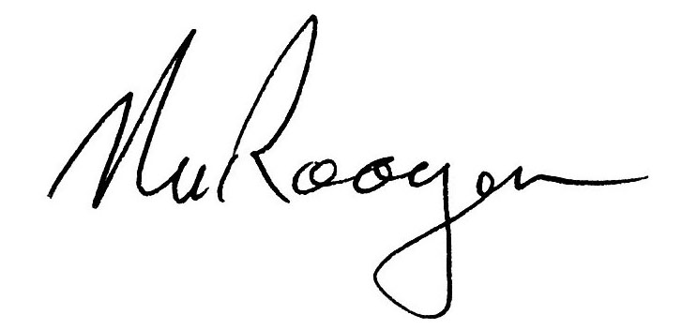
---------------------------------
Dr. Noel van Rooyen

Member: N van Rooyen: DSc, PrSciNat (Reg nr 401430/83), SAIE&E, GSSA,

